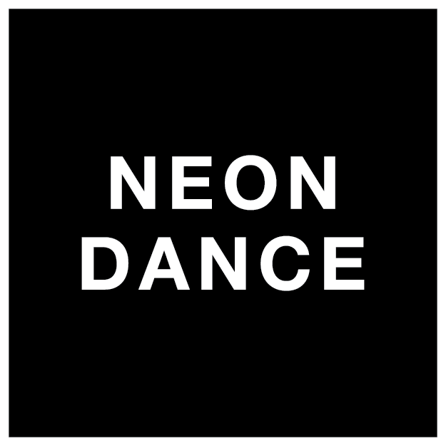

EQUAL OPPORTUNITIES MONITORING FORM

Neon Dance is committed to ensuring that all job applicants and members of staff are treated equally, without discrimination on the grounds of gender, sexual orientation, marital or civil partner status, gender reassignment, race, colour, nationality, ethnic or national origin, religion or belief, disability or age. This form is intended to help us maintain equal opportunities best practice and identify barriers to workforce equality and diversity.
Please complete this form and return it with your application. The form will be separated from your application on receipt. The information on this form will be used for monitoring purposes only and will play no part in the recruitment process.
All questions are optional. You are not obliged to answer any of these questions but the more information you supply, the more effective our monitoring will be.

Thank you.

ABOUT THE VACANCY
Job applied for: ________________________________
Closing date: ________________________________
Where did you hear about this job: ________________________________

GENDER:
Male ☐ Female ☐ Non-Binary ☐ Prefer not to say ☐

SEXUAL ORIENTATION:
Bisexual ☐ Gay Man ☐ Gay Woman/Lesbian ☐ Heterosexual/Straight ☐
Queer ☐ Prefer not to say ☐

AGE:
16-19 ☐ 20-34 ☐ 35-49 ☐ 50-64 ☐ 65+ ☐
Prefer not to say ☐

DO YOU IDENTIFY:
As a disabled person ☐ Non-Disabled ☐ Prefer not to say ☐

ETHNICITY:
How would you describe your ethnic origin? Please tick one of the below:

White
☐ British
☐ Irish
☐ Gypsy or Irish Traveller
☐ Any other white background, please state________________________________

Asian or Asian British
☐ Bangladeshi
☐ Indian
☐ Pakistani
☐ Chinese
☐ Any other Asian background, please state________________________________

Black or Black British
☐ Black African
☐ Black Caribbean
☐ Any other Black background, please state _________________________________

Mixed
☐ White & Black Caribbean
☐ White & Black African
☐ White & Asian
☐ Any other background, please state______________________________________

Other
☐ Arab
☐ Prefer not to Say
☐ Any other background, please state____________________________________

CARING RESPONSIBILITIES:
Do you have caring responsibilities? If yes, please tick all that apply

- None
- Primary carer of a child/children (under 18)
- Primary carer of disabled child/children
- Primary carer of disabled adult (18 and over)
- Primary carer of an older person
- Secondary carer (another person carries out the main caring role)
☐ Prefer not to say

